**Bread**

Cinnamon Rolls (pt. 1)

**Directions (pt. 1)**

For stand mixer:

Warm mixer bowl by rinsing with hot water. Heat water to 110°F (1 min @ 50% power). Dissolve yeast in warm water in warmed bowl.

In 2-cup glass measuring cup, heat milk, sugar, salt and butter (2 min @ 50% power). Cool to lukewarm-110˚ºF. Add lukewarm milk mixture to water/yeast in mixer bowl.

Add 7 C flour to yeast/milk mixture in mixer bowl. Attach bowl and dough hook to mixer. Turn to Speed 2 and mix about 1 minute.

Continuing on Speed 2, add remaining flour, ½ cup at a time, and mix about 2 minutes, or until dough clings to hook and cleans sides of bowl. Knead on Speed 2 about 2 minutes longer, or until dough is smooth and elastic. Dough will be slightly sticky to the touch.

**Ingredients**

**Bread:**

**2 T + ¾ tsp – 3 packages quick rise yeast**

**2 ¼ C – warm water**

**¾ C – milk**

**4 ½ T – sugar**

**1 T -salt**

**4 ½ T – butter**

**8-9 C – bread flour**

**Caramel:**

**1 C – brown sugar**

**6 T – butter**

**2 T – corn syrup**

**MAKES**

**Two dozen rolls**

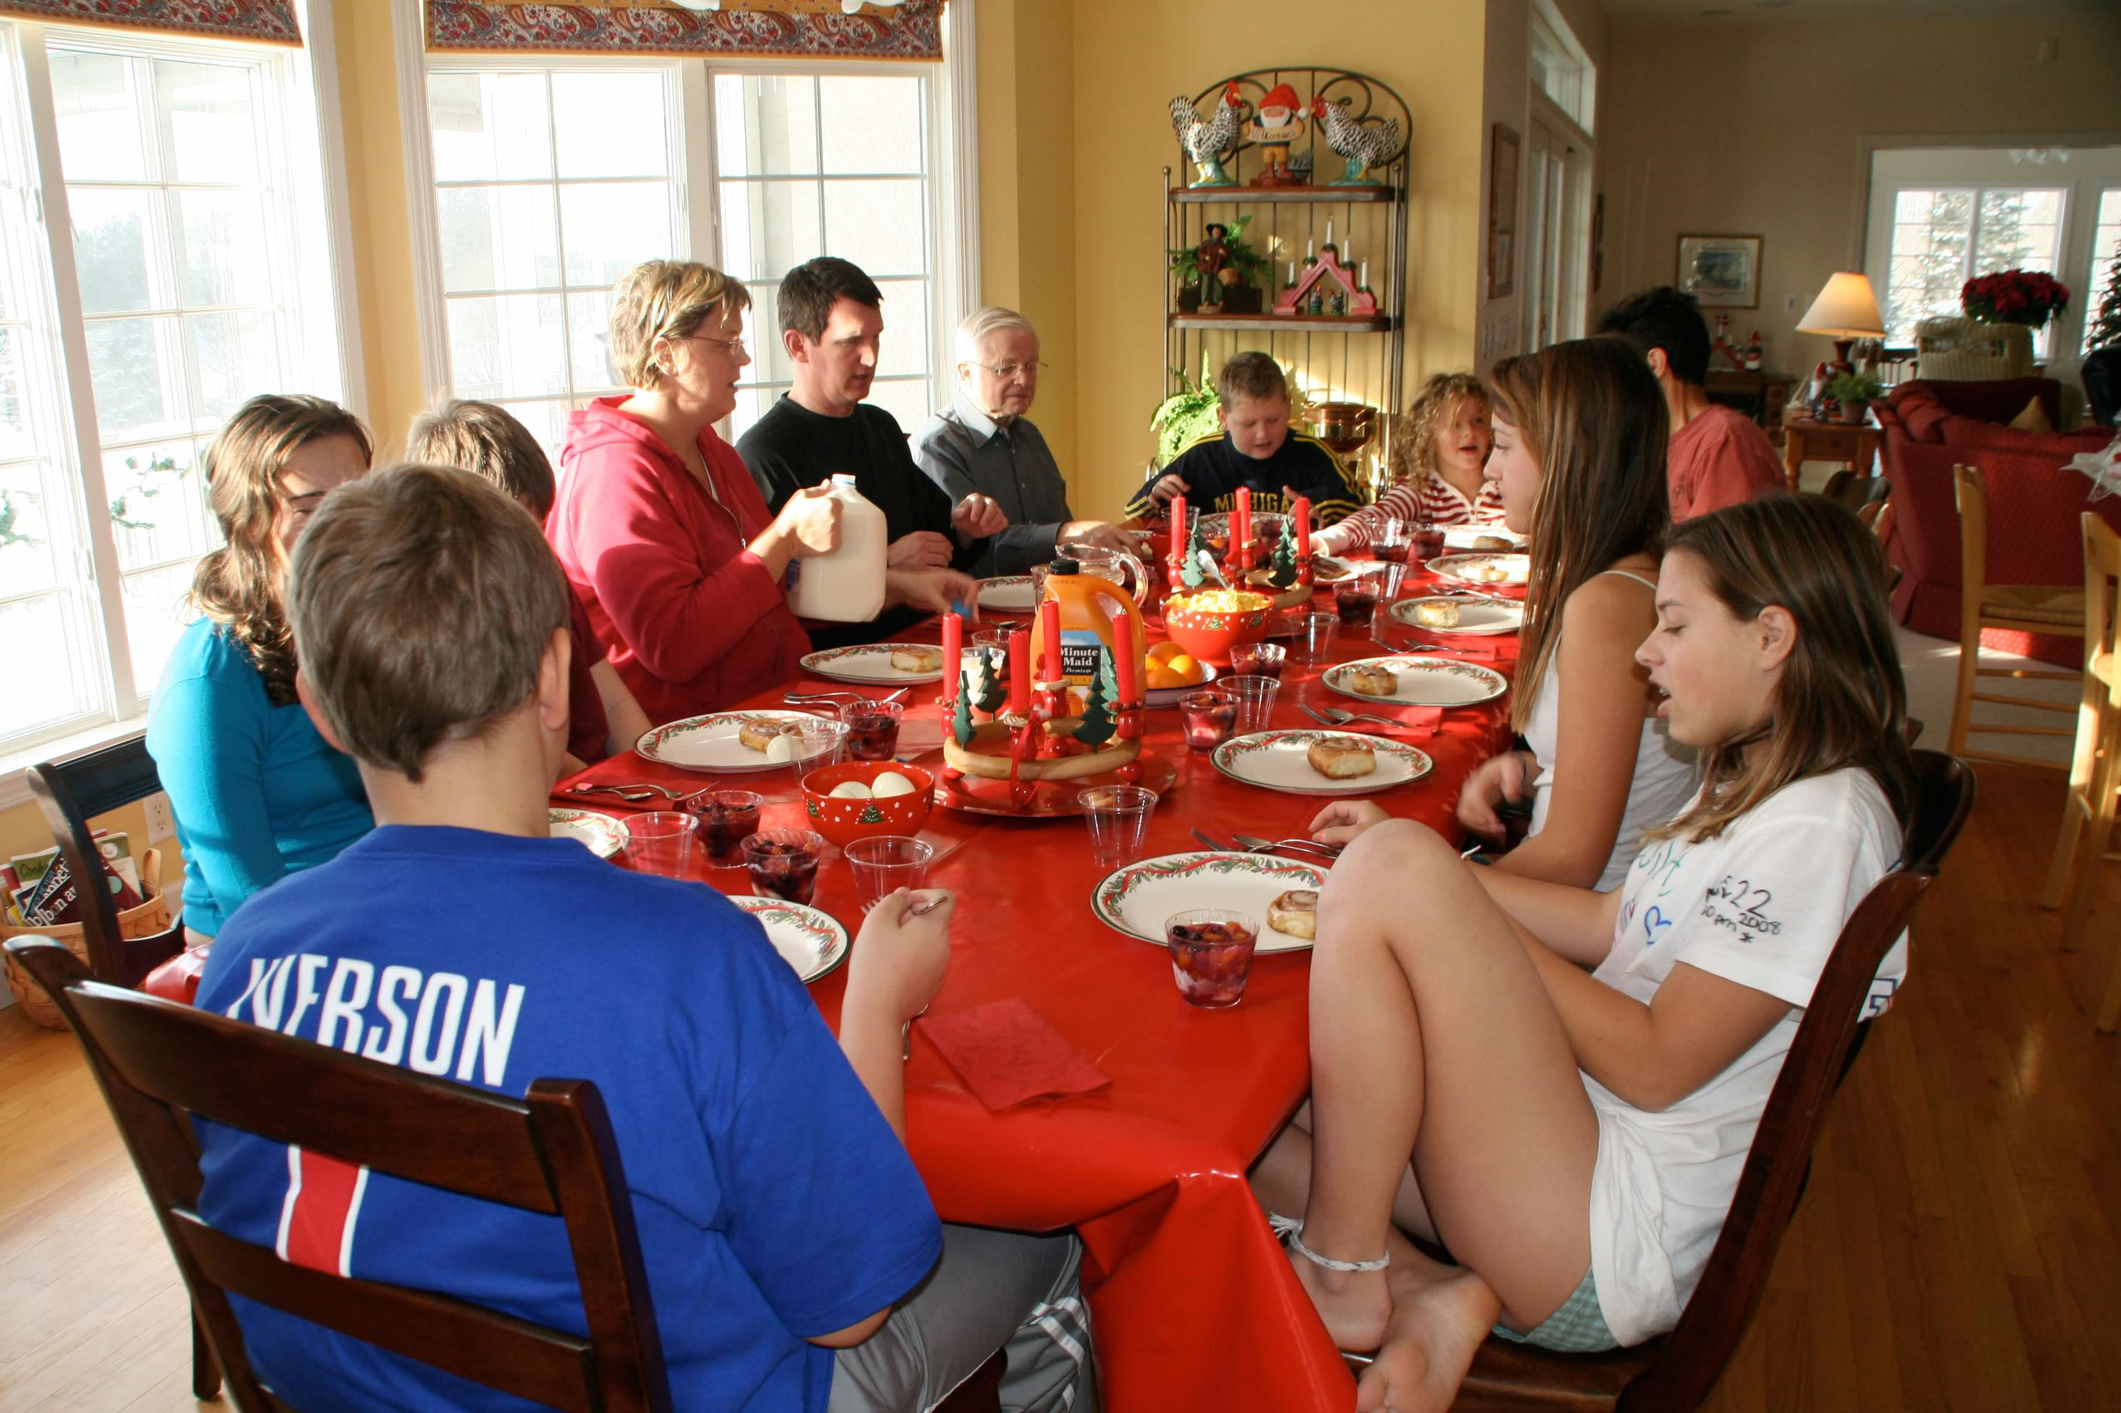

**Bread**

Cinnamon Rolls (pt. 2)

**Directions (pt. 2)**

Place dough in greased bowl, turning to grease top. Cover. Let rise in warm place, free from draft and covered with a towel, about 1 hour or until doubled in bulk.

Punch dough down and divide in half. Roll or pat out dough into an approximately 9x15” rectangle. Spread dough with room temperature butter, sprinkle with brown sugar, then with cinnamon. Form a tight spiral roll by rolling dough lengthwise. Pinch the end of the dough to the roll. Cut into 12 spiral pieces and place in greased baking 9x13 cake pans.

Cover rolls and let rise in warm place for 1 hr (double size)

Coat bottom of the pan with caramel mixture: brown sugar, butter, corn syrup microwaved for 3 min @ 30%.

Bake at 350º for 20-30 minutes, or until golden brown. Remove from pans immediately and cool on wire racks.

**Ingredients**

**Bread:**

**2 T + ¾ tsp – 3 packages quick rise yeast**

**2 ¼ C – warm water**

**¾ C – milk**

**4 ½ T – sugar**

**1 T -salt**

**4 ½ T – butter**

**8-9 C – bread flour**

**Caramel:**

**1 C – brown sugar**

**6 T – butter**

**2 T – corn syrup**

**MAKES**

**Two dozen rolls**

